INTRODUCTION
Construction of a feedback-controlled positioning system for the Eöt-Wash LISA small force measurement
Colin Connolly, Stanford University
advisor: Jens Gundlach
UW Research Experiences for Undergraduates Program in Physics

We constructed a positioning system for the attractor plate of the Eöt-Wash LISA small force measurement feedback-controlled via software using position input from an infrared laser position sensor. The system was used to drive a simulated attractor plate in sinusoidal motion with average precision of one micron. The systematic influence of hysteresis in the piston pump was the limiting factor; an improved pump should improve the performance of the system by nearly an order of magnitude.
Direct evidence for gravitational waves (GW) has yet to be found. Observations of the PSR 1913 + 16 binary pulsar have indirectly indicated their existence, but current observatories still lack the sensitivity necessary to observe GW events on laboratory timescales. The Large Interferometer Space Antenna (LISA) is a joint collaboration between NASA and the European Space Agency (ESA) that will achieve sensitivities great enough to observe GW events such as black hole mergers and potentially map the GW background left over from the creation of the universe.
The LISA satellites will form vertices of an equilateral triangle in space with laser beams traveling between them. Each satellite will serve as an interferometer. The laser beams will reflect from cubical metal proof masses within each spacecraft. For LISA to achieve its target sensitivity of a 10⁻²³ minimum fractional length change, any force coupling of the proof masses to the spacecraft must be eliminated. The 2- to 4-mm spacing between the proof masses and spacecraft housing potentially allows for small forces between the metal surfaces. Forces due to patch effect potentials are one class of small forces that has not been studied in much detail. Macroscopic metal surfaces are a mosaic of patches of different exposed crystal planes with different surface dipole moments. A difference in the work function of two closely-spaced metals causes a small voltage between them. The forces due to this effect are expected to be small, but may be large enough to require greater spacing between the proof masses and spacecraft for the LISA observatory.
Measurement of these small forces, as well as others due to outgassing, thermal gradients or other effects, is being made with a torsion step pendulum by the Eöt-Wash group at the University of Washington. The pendulum will be driven by a closely-spaced attractor plate which will move sinusoidally over a range of about 1 to 2 mm. To avoid electrostatic coupling the attractor plate will be moved with an oil bellows fed by a tube from outside the vacuum chamber.
This paper details the construction of a feedback-controlled positioning system for the attractor plate component of the Eöt-Wash small force measurement for LISA.

EXPERIMENTAL METHOD
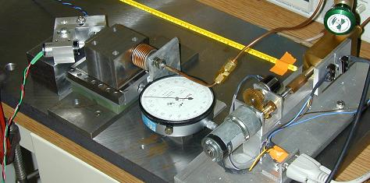
The experimental apparatus for the feedback-controlled positioning system can be summarized as three interdependent systems: first, the infrared laser position sensor; second, the motor-driven positioning system; and third, the software feedback loop. The sensor feeds position information to the feedback loop, where the information is analyzed and an output voltage is produced. This voltage drives the positioning system, which directly influences the sensor’s measurement. User control on the software side defines the equilibrium point.
FIG 1: Experimental setup: the motor and pump assembly at right drives the bellows at center to move the steel block at left. The position of the block is measured by the position sensor at left.
The position sensor consists of an infrared laser beam reflecting from a moveable mirror onto a split photodiode. The laser beam is generated by a 5-mW infrared semiconductor laser. The light passes through a lens and collimator to produce a parallel beam 1.1 mm in diameter. The beam strikes the mirror with an incident angle of 45º and reflects to reach the photodiode orthogonally. As the mirror moves along the normal, the beam translates across the photodiode surface. The dynamic range of the position sensor is approximately 1 mm. The fraction, θ, of the differential photocurrent between the two sides of the photodiodes to the total photocurrent is roughly linear in mirror displacement over that range.
The positioning system compares its input voltage to a voltage divider output via a high-gain differential amplifier and a push-pull transistor driver to power the motor. The voltage divider is set by a geared multi-turn potentiometer driven by a gear on the motor shaft. The turning of the motor drives a hydraulic piston which draws or pushes oil through a tube to a copper bellows in contact with the mirror mount. Since the piston location defines the potentiometer voltage, choosing an input voltage will cause the motor to spin in the appropriate direction until the voltage difference is eliminated and the piston has reached the desired location.
The choice of input voltage is made by a modified PID feedback loop. The loop defines the current error as the difference between the current position measurement and the target position. The sum of two terms, a P term proportional to this error and an I term proportional to the integral of the error over time, defines the output voltage to the positioning system. The usual D term proportional to the change in error is omitted because phase delays causes it to increase the noise in the system. An additional Gaussian envelope limits the range of the I term to very small errors and a corresponding Gaussian notch limits the P term’s effect for small errors while preserving it for large errors. With this notch, the P constant can be set very high so that it supplies a strong restoring force to keep the mirror near its target position, yet it will not cause the output to become unstable near the target. Likewise, the I term will only change significantly once the P term has reduced the error to a manageable level, reducing unwanted overshoot.
A hysteresis was observed in the piston’s performance. When the piston changed direction, there was a “dead zone” in which the motor would spin without oil flowing, presumably due to the o-ring in the piston assembly rolling over. To overcome this effect, the feedback loop coupled to every large direction change a short (approximately 700-ms) burst of maximum voltage to preserve linearity.

RESULTS AND ANALYSIS
Two periods of sinusoidal plate motion are displayed in Figure 2. The lower peaks follow a sine wave closely with only a small effect of the piston hysteresis still visible. The peaks for positive θ, however, show a sharp step and are followed by recovery oscillations. The step is caused by the voltage burst, since the “dead zone” is not truly “dead” when going in the negative θ direction. When the motor spins quickly for the burst period there is a small oil movement that jogs the measurement off the target. There is then a “dead zone” in the other direction as the feedback loop attempts to compensate. This unwanted effect is comparable in magnitude to the motor motion without applying a burst. Thus the burst was only effective for half of the peaks.
While the voltage burst was not able to eliminate the effects of the piston hysteresis, the waveform is still very reproducible. The blue points in Figure 3 are a superimposition of all 50 periods of the data set. The red points are the residuals of each period from a spline of a single period (the period chosen for the spline was the one that minimized the average residuals). The horizontal lines are the 1-σ average deviation. Clearly the points of greatest nonreproducibility occur at the upper peaks at the onset of and during the recovery from the voltage burst.
The red curve in Figure 4 shows twice the average standard deviation of a set of one point from each period for each point in time (e.g. a set of all the first points, a set of all the second points, etc.). The plate position deviated from the target within these bounds for 95% of the data collected. The quiet region before the top peak is very calm, the position staying within half a micron of the target very consistently. It is then reasonable to expect that if the hysteresis was removed then there would be no large deviation from this noise level.
Figure 5 is a Fourier transform of the periodic motion. The 300-s period component is clearly visible, as is a small second harmonic near 6.7 mHz and a multitude of resonances with periods of less than 10 s. These high-frequency peaks are natural recovery frequencies of the positioning system and would be much smaller if the system maintained consistent sub-micron accuracy, thus avoiding the need to recover. The size of the second harmonic should also be reduced by smoothing the top peak. All these contributions are at least two orders of magnitude weaker than the 300-s resonance, however, especially near the primary resonance itself.

SUMMARY
The positioning system was observed to reproducibly maintain the mirror on average within a micron of its target, although deviations of 5 to 8 microns were observed from the common waveform. The limiting factor is the hysteresis of the piston in the positioning system. It is reasonable to estimate a factor of 5 to 10 improvement with the elimination of the hysteresis alone. The infrared laser position sensor is sensitive to at least this precision.
The hysteresis could be eliminated by the use of a peristaltic pump, which could also potentially increase the resolution of the positioning system, as well; or by the use of a second bellows instead of a piston.

ACKNOWLEDGEMENTS
I am very grateful for the guidance and patience of Jens Gundlach. I also very much appreciate the advice, assistance and expertise of Stephan Sclamminger and Eric Swanson.

REFERENCES

C. C. Speake, Class. Quantum Grav. 13, A291 (1996)
L. Carbone et al., Achieving geodetic motion for LISA test masses: ground testing results, (2003)
J.B. Camp et al., J. Appl. Phys. 71 783 (1992)
J.B. Camp et al., J. Appl. Phys. 69 7126 (1991)

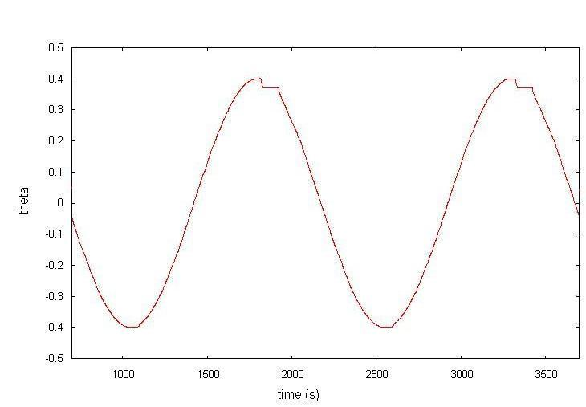
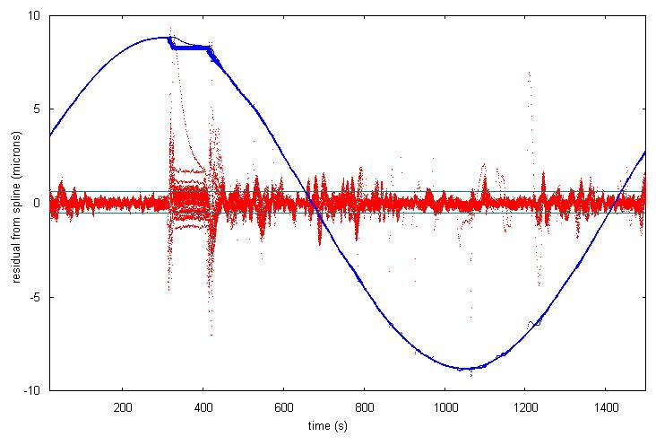
FIG 3: 50 periods of attractor plate motion (blue, printed for phase information); residuals from cubic spline of one period (red).
FIG 2: two periods of attractor plate motion.
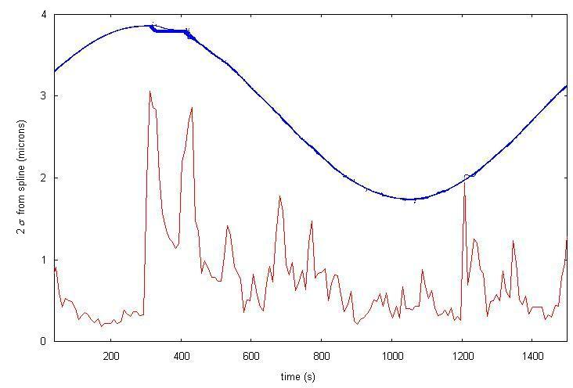
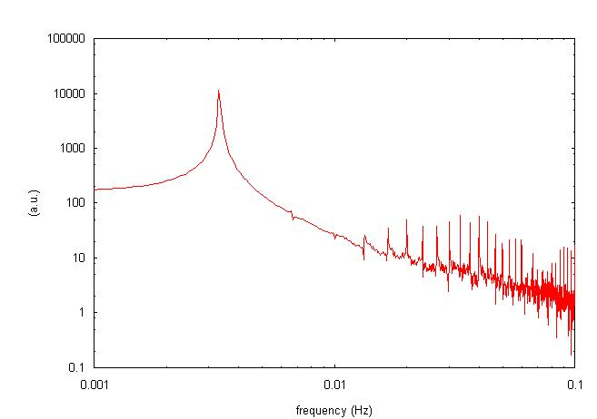
FIG. 5: Fourier transform of attractor plate motion
FIG. 4: Two-σ deviation of averaged data from cubic spline. The attractor plate motion was within these bounds 95% of the time.

