Single Ba⁺ Ion Trapping and Laser Modulation

Amelia Bloom

August 27, 2003

Abstract

Trapped single ions are being used by many groups for high precision spectroscopy, next-generation clocks and frequency standards, quantum computers, and studies of fundamental symmetries. At the University of Washington, the Fortson group is currently trapping single ions of Ba⁺ for high precision spectroscopy and plans on studying fundamental symmetries in the future. I will explain briefly how the ion trap works, what measurements are being taken and will be taken in the future, and some of what will be involved in switching from trapping ¹³⁸Ba⁺ to ¹³⁷Ba⁺.

Trapping

The ion trapping takes place in a ring approximately 1 mm in diameter whose voltage is oscillated at 10 MHz. Barium atoms heated from an oven and electrons ejected from a filament meet in this ring until an atom becomes ionized. The rapidly varying voltage catches the ion in a pseudopotential and forces it to move about the center position. A blue laser at 493 nm, which corresponds to the 6S_{1/2} to the 6P_{1/2} transition, is kept slightly red shifted so that the ion only absorbs the light when moving towards it. This acts to cool the ion and decrease its motion. As can be seen from the energy diagram (Figure 1), if the ion is in the 6P_{1/2} state spontaneous decay is possible to the very long lived 5D_{3/2} state. However, for efficient cooling, we want the ion to spend as much time in the 6S_{1/2} to the 6P_{1/2} transition where it is being cooled. Therefore, a red laser at 650 nm is needed to pump the ion out of the 5D_{3/2} state and back into the 6P_{1/2} state.

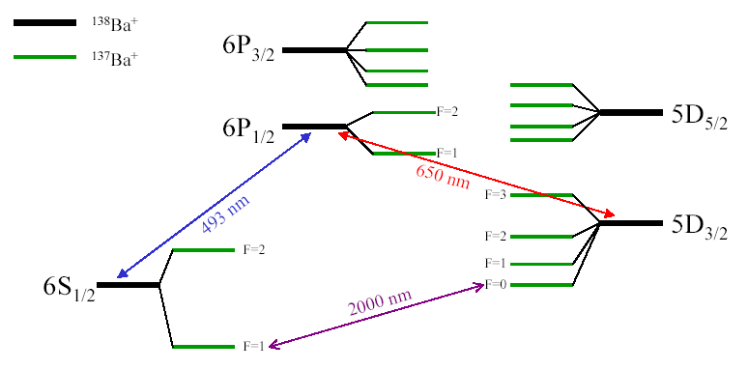
Figure 1: Energy-level diagram of ¹³⁸Ba⁺ and ¹³⁷Ba⁺

Studies in ¹³⁸Ba⁺

Currently, we measure the Zeeman effect due to an applied magnetic field, and the Light Shift (or ac-Stark effect) due to circularly polarized off resonant light. An external highly stable magnetic field is applied breaking the degeneracy of magnetic quantum numbers. The Light Shift causes the energies of Zeeman sublevels to change. See Figure 2. In the future we would like to use a Light Shift technique to measure atomic parity nonconservation. Parity is conserved when the results of an experiment or calculation have reflection symmetry. A good example of parity conservation is a game of pool with a mirror above the table. It does not matter if one looks directly at the table where the balls actually are or if one watches the mirror. The momenta and angles if collisions will be the same regardless of where you are looking. In the case of physics involving the weak force, however, this is not always the case, and we want to measure the extent to which this occurs inside the Ba nucleus. For many reasons, it will be much easier to measure parity nonconservation using the 6S_{1/2} F=1 to 5D_{3/2} F=0 transition in ¹³⁷Ba⁺. This is the main reason that we want to switch from trapping ¹³⁸Ba⁺ to trapping ¹³⁷Ba⁺, though the same transition is very attractive for an ion-based clock.

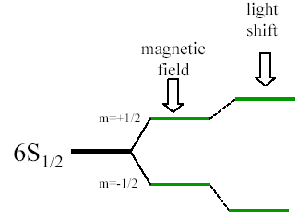
Figure 2: An example of Zeeman splitting and the light shift

Laser Modulation

As seen in the energy diagram (Figure 1), ¹³⁷Ba⁺ requires four different red laser frequencies since the 5D_{3/2} level splits into four distinct energy levels due to the overall nonzero spin of the nucleus. Unfortunately not one of these frequencies corresponds with the frequency put out by the red laser currently in use (see Figure 3). Since buying four new lasers and four sets of frequency locking equipment would be very expensive, we would prefer to modulate the light so that we can get all four frequencies from the 650 nm diode laser currently in use. In addition to getting all four frequencies out of the single laser, we would also like to be able to turn the different frequencies off and on at will. The three possible laser modulation schemes that we have been investigating this summer are the double pass acousto-optic modulator (AOM), the resonant electro-optic modulator (EOM) with sideband selector, and the frequency cycling broadband EOM.
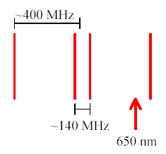
Figure 3: A spectrum of the red frequencies needed to trap ¹³⁷Ba⁺

First I will explain how the AOM works. An AOM is a crystal which has a radio-frequency (RF) applied to it. This creates standing waves of sound in the crystal. Since standing waves consist of oscillating high and low pressures, this creates a sinusoidally changing index of refraction within the crystal which causes the light to diffract and shifts the frequency of the input beam by multiples of the applied RF as seen in Figure 4. The Bragg angle is the angle of the input beam that maximizes the intensity of the first order. If the beam is at some other angle, multiple orders to either side of the 0th order can be produced simultaneously but with much weaker intensities.
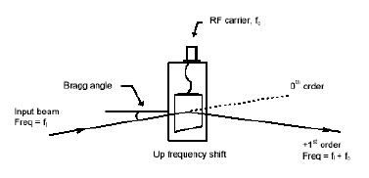
Figure 4: An illustration of an AOM shifting some of the input beam by the applied RF.

For the double pass AOM scheme, our laser frequency is to be broadened to 140 MHz wide, which is easily be done by modulating the diode laser’s peizo-electrically mounted grating. Then the beam is then passed through an AOM to shift the frequency so that it is centered with regards to all four needed frequencies. Since it has a width of 140 MHz, our center two lines will be covered (Figure 3). The light will then pass through apparatus as shown in Figure 5. The polarization will be aligned so that all the light will go straight through the polarizing beam splitter. The AOM will be aligned to produce light of the original frequency (carrier) as well as that of 200 MHz above and below the original frequency (sidebands). Since the three frequencies are now separated in space, they can be easily shuttered to control the different frequencies independently. The spherical mirror sends the beams back along the same path to enter the AOM at the same angle at which they left. For this reason all three beams will come back out in a single beam. The two sidebands will shift by another 200 MHz, making their final frequencies 400 MHz to either side of the carrier. The quarter-wave plate serves the purpose of circularly polarizing the light the first time it passes through, and then changing it back into linearly polarized light rotated by 90º when it passes through the second time. This makes the light reflect off the beam splitter instead of going straight through so that it doesn’t go back into the laser. The problems with this scheme are that we cannot control the middle frequencies independently and that, as of yet, we do not know if we can get enough laser power into the sidebands.

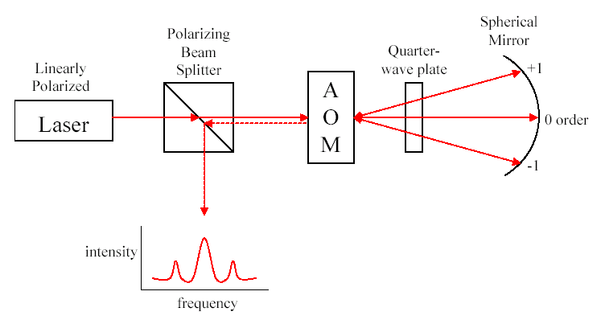
Figure 5: Double-Pass AOM Scheme for Frequency Modulation

The EOM is also composed of a crystal and has RF applied to it. In this case, however, the crystal is birefringent and is inside of a capacitor which is connected to the RF source. The capacitor creates a strong electric field that interacts with the dipolar molecules of the crystal causing the index of refraction to change. When enough RF voltage is applied to the capacitor, the light will contain both the original frequency and frequencies shifted by plus or minus the applied RF. In this case however, the different frequencies of light are not diffracted and so come out in a single beam.
The second scheme, a resonant EOM with sideband selector, also requires the same broadening and shifting of the laser frequency as the double pass AOM scheme does. Since the light will only pass through the EOM once, a 400 MHz resonant EOM is required. Since the carrier and the sidebands are never separated in space, another method must be used to extinguish one or more of the frequencies. To accomplish the beam is split using a beam splitter. One of the resulting beams is left untouched. The other beam is passed through either another EOM or a Pockel’s cell so that the path length can be controlled. The two beams are then merged, and because they are out of phase, interference can eliminate one or both of the sidebands and/or the carrier. Because of the broadening, this scheme also has the problem that the middle frequencies cannot be controlled independently. Another problem is that we are uncertain if we can, in practice, totally eliminate one or more of the frequencies.
The third possible scheme is frequency cycling a broadband EOM. This requires an EOM that will work for a large frequency range. The input RF can electronically controlled to cycle through all four of the needed lines. To extinguish a certain frequency, we can simply skip over it when cycling through. The advantages of this scheme are that it is the only one in which the center frequencies can be independently controlled, and it is the only one in which the laser does not have to be shifted initially.
As of yet it has not been decided which laser modulation scheme will work best. Much more research should be done before a final decision is made. In the time I have left I hope to make power measurements of how much power is actually getting into the sidebands using the AOM scheme.

Acknowledgements

I would like to thank the NSF for funding my work this summer, and the University of Washington and INT for hosting this program. I would also like to thank my advisor, Norval Fortson, and the grad students who I worked with, Jeff Sherman and Timo Koerber.

References

Ion Trapping:

N. Yu, W. Nagourney, and H. Dehmelt, “Radiative Lifetime Measurement of the Ba⁺ Metastable D_{3/2} State,” Physical Review Letters 78, 26 (1997).

J.C. Bergquist, Randall G. Hulet, Wayne M. Itano, and D.J. Wineland, “Observation of Quantum Jumps in a Single Atom,” Physical Review Letters 57, 14 (1986).

Quantum Computing:

Ralph G. DeVoe and Christian Kurtsiefer, “Experimental Study of Anomalous Heating and Trap Instabilities in a Microscopic ¹³⁷Ba Ion Trap,” Physical Review A 65, 063407 (2002).

C. Monroe, D.M. Meekhof, B.E. King, W.M. Itano, and D.J. Wineland, “Demonstration of a Fundamental Quantum Logic Gate,” Physical Review Letters 75, 25 (1995).

Clocks:

P.J. Blythe, S.A. Webster, K. Hosaka, and P. Gill, “Systematic frequency shifts of the 467 nm electric octupole transition in ¹⁷¹Yb⁺,” Journal of Physics B: Atomic, Molecular and Optical Physics 36 (2003).

Wayne M. Itano, “External-Field Shifts of the ¹⁹⁹Hg⁺ Optical Frequency Standard,” Journal of Research of the National Institute of Standards and Technology 105, 6 (2000).

Precision Spectroscopy:

T.W. Koerber, M. Schadt, W. Nagourney, and E.N. Fortson, “Radio frequency spectroscopy with a trapped Ba⁺ ion: recent progress and prospects for measuring parity violation,” Journal of Physics B: Atomic, Molecular and Optical Physics 36 (2003).

